***ASSIGNMENT 2.2***

***NAME : BHAWWANA SHRE***

***H.NO : 2403A52311***

***SUBJECT : AI ASSISTANT CODING***

***BATCH : 01***

***\*Prompt :***

***"Write a Python function sum_even_odd(numbers) that takes a list of integers as input and returns a tuple containing the sum of even numbers and the sum of odd numbers in the list”.***

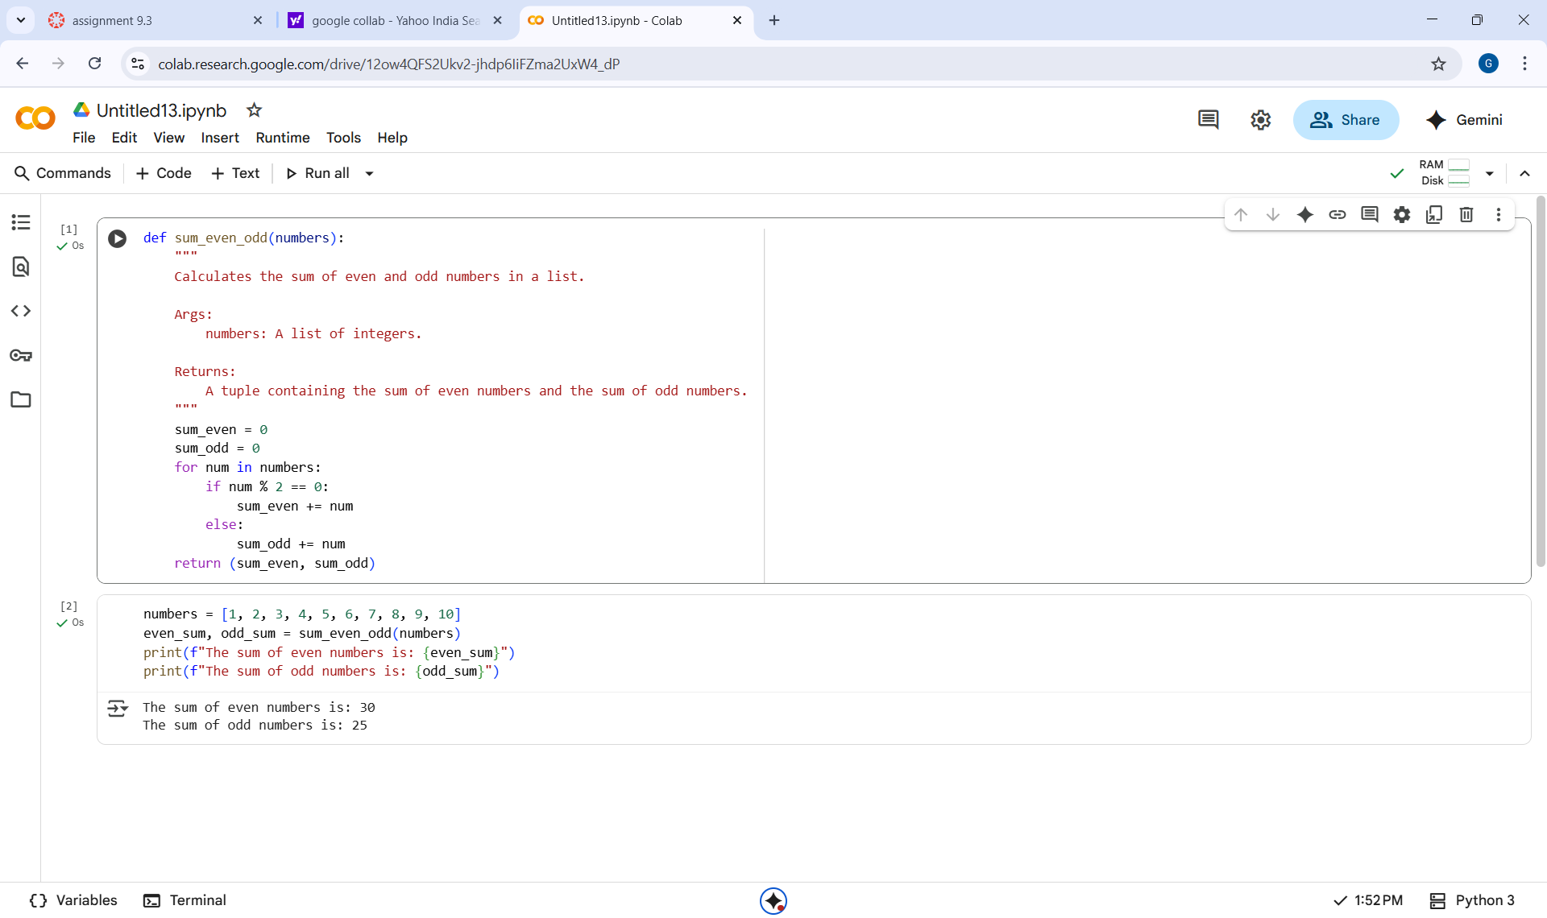***Code :***

***Output :***

***The sum of even numbers is: 30***

***The sum of odd numbers is: 25***

***Observation :***

***The code defines a function sum_even_odd that successfully separates and sums the even and odd numbers in the provided list my_list.***

***The list my_list contains integers from 1 to 10. The even numbers in the list are 2, 4, 6, 8, and 10. Their sum is 30.***

***The odd numbers in the list are 1, 3, 5, 7, and 9. Their sum is 25. The code correctly calculates and prints these sums as shown in the output:***

***\*prompt :***

***Create a Python class sru_student with the following attributes: name, roll_no, and hostel_status. Implement methods fee_update and display_details.***

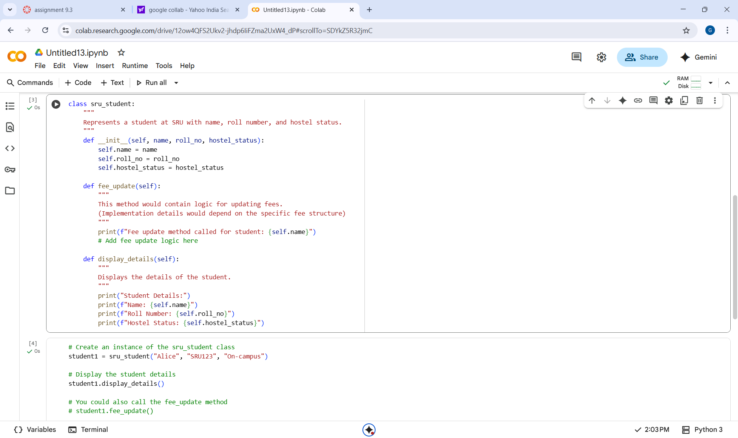***Code :***

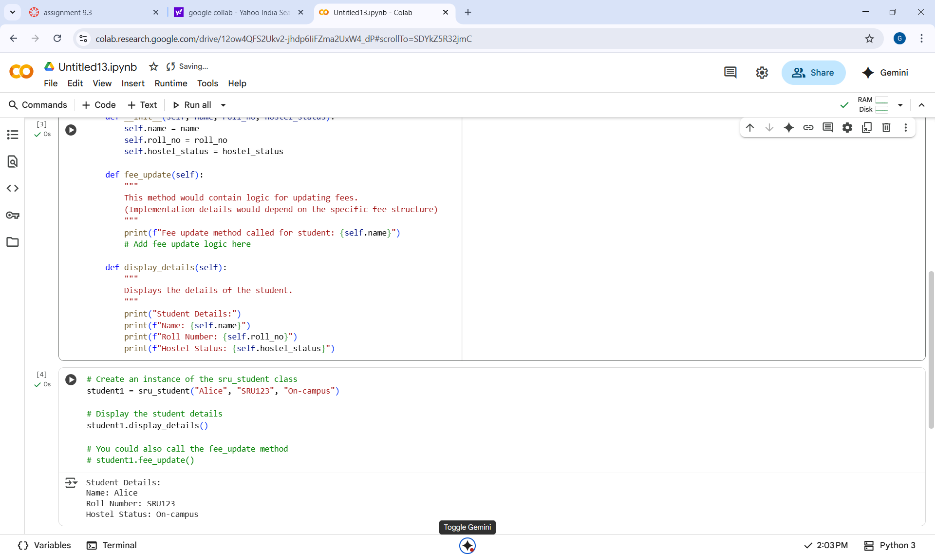

***Output :***

***Student Details:***

***Name: Alice***

***Roll Number: SRU123***

***Hostel Status: On-campus***

***Observation :***

***I've created the sru_student class with the requested attributes and methods, and included example usage.***

***Add more methods to the sru_student class (e.g., a method to check hostel eligibility).Create more instances of the sru_student class with different details.***

***Explore how to store a list of sru_student objects.***

***\*prompt :***

***Create a Python script with 3–4 calculator functions (e.g., add, subtract, multiply, divide).***

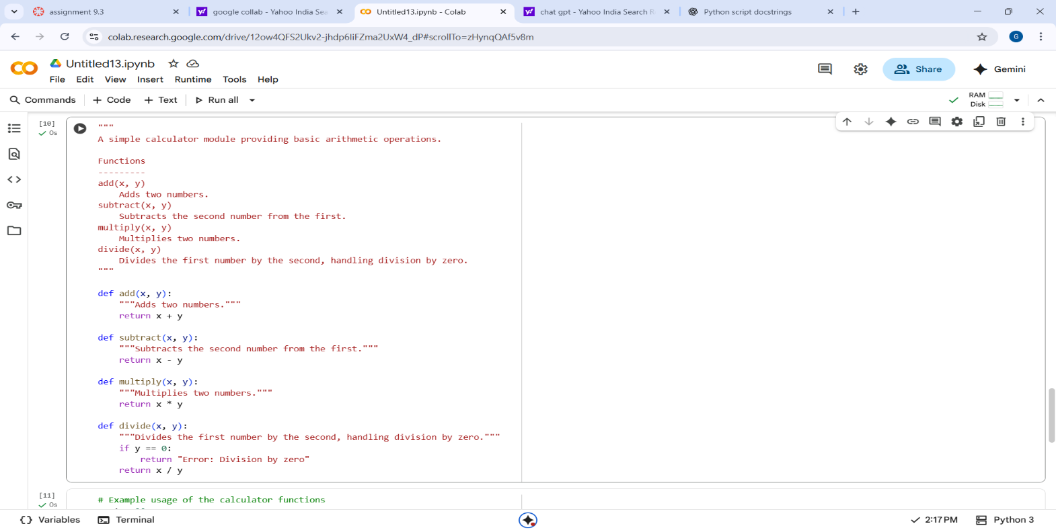***Code :***

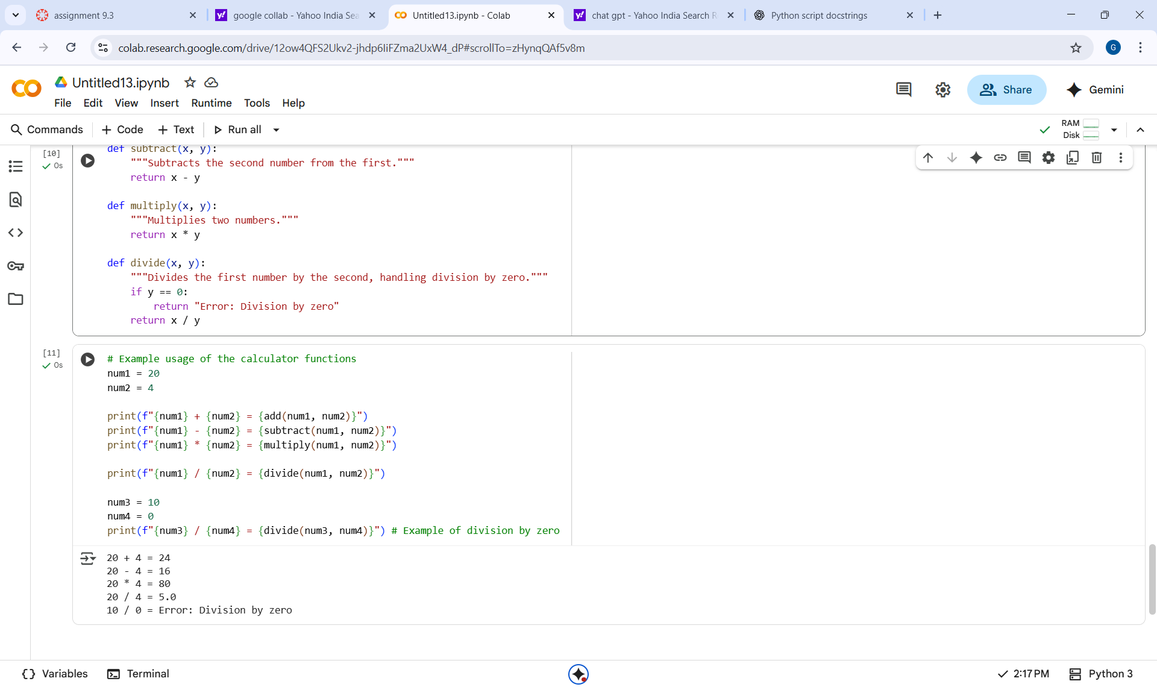***\****

***Output :***

***20 + 4 = 24***

***20 - 4 = 16***

***20 * 4 = 80***

***20 / 4 = 5.0***

***10 / 0 = Error: Division by zero***

***Observation :***

***The code defines a simple calculator module with add, subtract, multiply, and divide functions. Each function includes clear NumPy-style docstrings explaining its purpose, parameters, and return value. The divide function correctly handles division by zero by raising a ZeroDivisionError.***